*Lab Sheet 5*

*Question 4*

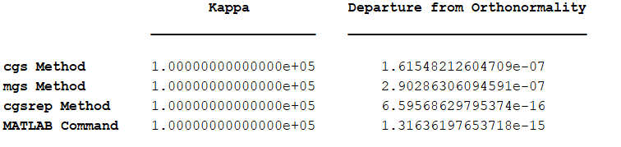

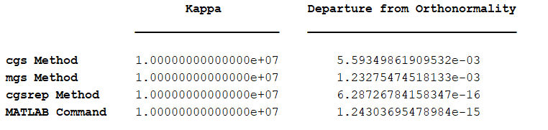

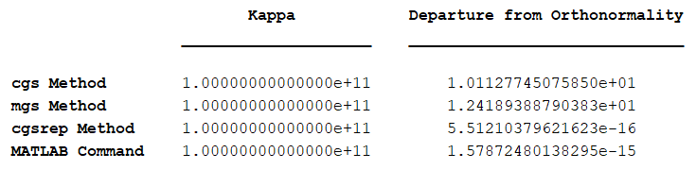

The MATLAB command qr(A,0) and the cgsrep method both give low values for departure from orthonormality across all condition numbers.

In comparison, cgs and mgs methods give poorer results. The results for cgs and mgs become even more inaccurate for higher condition numbers.